Adding Files to the SkyDrive

- In our Outlook email, click on the “More” button located at the top of the screen.

- Select Skydrive from the drop-down menu under MORE.
- This will open the SkyDrive. Notice that you can create Word, Excel, OneNote, and PowerPoint documents in the SkyDrive. 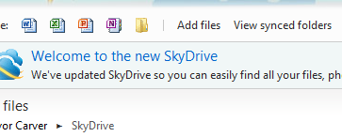
- From the above picture, look at the folder to the left of “add files”. Let’s create a folder first. Select “Make New Folder”. 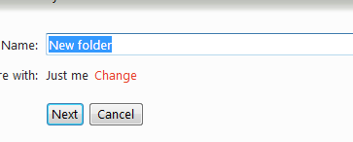
- Notice the “Share with”. I want my documents to be private, like teacher flipcharts, etc… You can select change to choose the appropriate style. 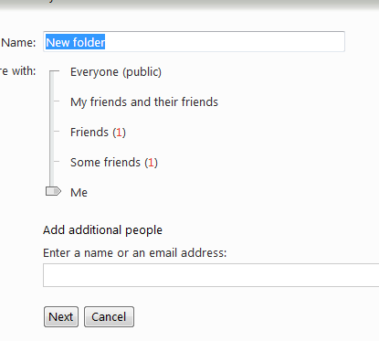
- Name the folder and you are ready to add files.
- Select “add files” and choose the appropriate folder.
- Choose “select documents from your computer”, search and find the file, and click open. When finished, click continue.
- It will upload directly to the SkyDrive, accessible anywhere you have an Internet connection. That’s it!

